

**RAMS – Reflect with Insight Integration Proposal**

To

Roads and Maritime Services

**Date**

**31st October 2013**



1.0 Proposal Outline 3

2.0 Implementation Plan 4

2.1 Development Environment Configuration 4

2.2 Production Implementation 4

2.3 Implementation Schedule 5

2.4 Assumptions 5

3.0 Pricing 6

3.1 Implementation Pricing 6

4.0 Proposal Acceptance 7

List of figures

Figure 5 - Implementation Schedule 5

# Proposal Outline

This proposal is for the implementation of a framework supporting integration of Reflect with Insight (RWI) work accomplishment information. The framework is also intended to support the integration of accomplishment data for other sources, besides RWI, using the same information requirements.

The deliverables for this project from Bentley are:

* RAMS metamodel design, documentation and implementation scripts
* Documentation of the data model relationships (ERD)
* Facilitation of design review meeting with RMS
* Setup of rules to ensure data integrity

# Implementation Plan

## Development Environment Configuration

The RWI Extraction Specification document will be used as a guide to develop and configure a baseline setup. This will include:

* Asset Metamodels
* Asset domain lists
* appropriate validation rules
* Spatial configuration
* CSV / Loader process and load specification
* Draft configuration documentation
* Sample data loaded and configured

Once the development environment has been configured, as day will be allocated where Bentley walk RMS staff through the configured solution in development explaining the details of what has been configured. This session will be used to validate and assumptions and identify any improvements or oversights during the initial development phase.

Bentley will include the agreed changes in the development environment and finalise configuration documents which will be agreed and signed off by RMS.

## Production Implementation

The agreed configuration developed and agreed during the development process will be implemented in the RAMS production. The implementation into production will include:

* Bentley providing documentation as required to include in a change request, if required
* Configuration of the production environment
* Loading of baseline dataset, to be supplied by RMS.

## Implementation Schedule

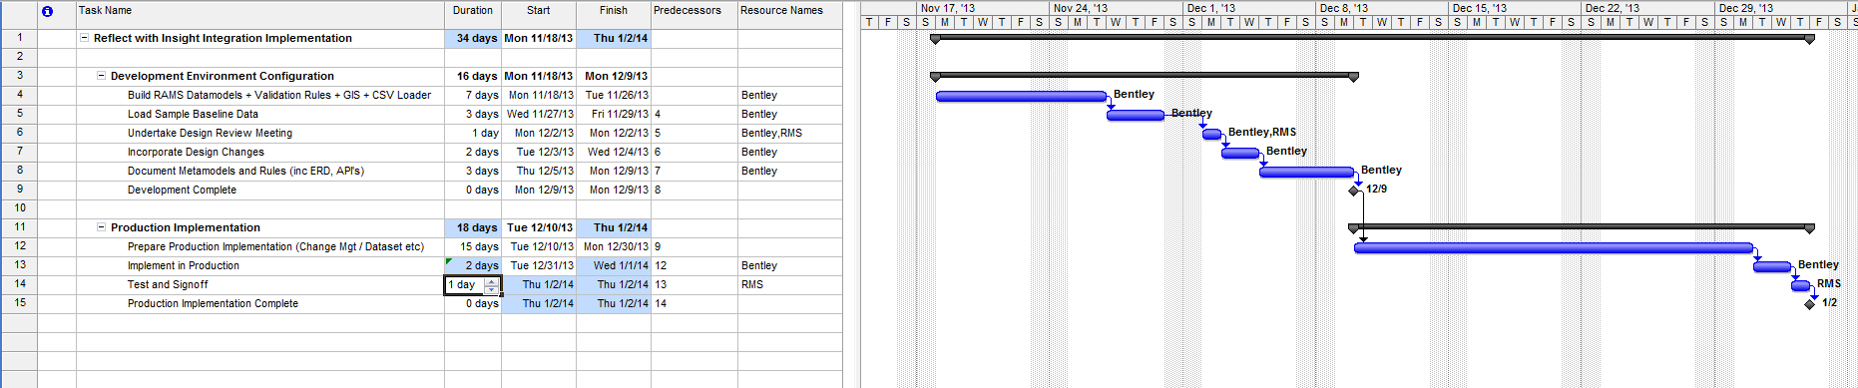

Figure 1 - Implementation Schedule

## Assumptions

# Pricing

## Implementation Pricing

The following pricing schedule is based on a time and materials basis funded through eCredits or day rates.

|  |  |  |  |  |
| --- | --- | --- | --- | --- |
|  | **Description** | **No. Days** | **Rate** | **Total** |
| 1 | Development Configuration | 7 | $2000.00 | $14,000.00 |
| 2 | Load Sample Data | 3 | $2000.00 | $6,000.00 |
| 3 | Design Review | 2 | $2000.00 | $4,000.00 |
| 4 | Incorporate Design Changes and Finalise Documentation | 5 | $2000.00 | $10,000.00 |
| 5 | Production Implementation | 3 | $2000.00 | $6,000.00 |
| 6 | Project Management | 3 | $2000.00 | $6,000.00 |
| **Sub Total** | | **23** |  | **$46,000.00** |
| **GST 10%** | |  |  | **$4,600.00** |
| **Total** | |  |  | $50,600.00 |

eCredits are a pre purchased technical support funding mechanisms for organisations. They provide a flexible, sliding scale for the provision of technical support services. The consumption of eCredits is detailed in a consultancy usage matrix which shows clearly the costs associated with using the eCredits.

Bentley eCredits are offered as two levels of package:

* eGold
* ePlatinum

Each package type consists of a set amount of pre paid consultancy credits.

|  |  |  |  |  |  |
| --- | --- | --- | --- | --- | --- |
| Package | No of Credits | Approx No Days at Consultant Rates | Sub Total | GST | Total (inc GST) |
| ePatinum | 700 | 29 | $50,500 | $5,050 | $55,550 |
| eGold | 289 | 11 | $22,500 | $2,250 | $24,750 |

These eCredits are utilized according to the sliding scale outlined below.

|  |  |
| --- | --- |
|  | Number of eCredits / day |
| Consultant | 24 |
| Project Manager / BPM | 24 |
| Senior Consultant | 28 |
| Trainer | 32 |

# Proposal Acceptance

This proposal for services is submitted and accepted by as indicated below. Please sign and return this proposal, as well as a Purchase Order, to Teena Rowlands. A signed Purchase Order is required before work can begin.

*Submitted by:*

___________________________

Teena Rowlands, Government Sector Manager, Bentley; Date

___________________________

James Wetherall, Services Director, Bentley, Date

*Accepted by:*

Signature

Printed Name, Company, Title, Date